



EducationalOrganizationUsingServiceNow

**Project Title**

**Team ID - NM2025TMID18633**

**Team Leader - PRAVEEN S**

**Team Member 1 - VIJAY D**

**Team Member 2 - VIMALRAJ P**

**Team Member 3 - VINISH KUMAR M**

**Problem statement**

Managing admissions, student progress, and administrative work in educational institutions is often done manually or through disconnected systems

objectives

*Automate admission and student progress process.

*Store all records in one centralized system.

*Reduce manual errors using validations.

*Provide real-time tracking for students and staff.

*Speed up admission and result processing.

*Handle large number of student records easily.

*Keep forms and workflows user-friendly.

skills

*ServiceNow Instance setup & configuration.

*Table creation and field design.

*Form layout & UI design.

*Number maintenance (Auto ID generation).

*Workflow creation for process automation.

*Client scripts for validation & calculations.

*Update set creation and migration.

*Testing & troubleshooting in Service Portal.

Step1: SettingUpServiceNow Instance

* GototheServiceNowDeveloperSite.(https://developer.servicenow.com/)
* SignIntotheDeveloperAccount.

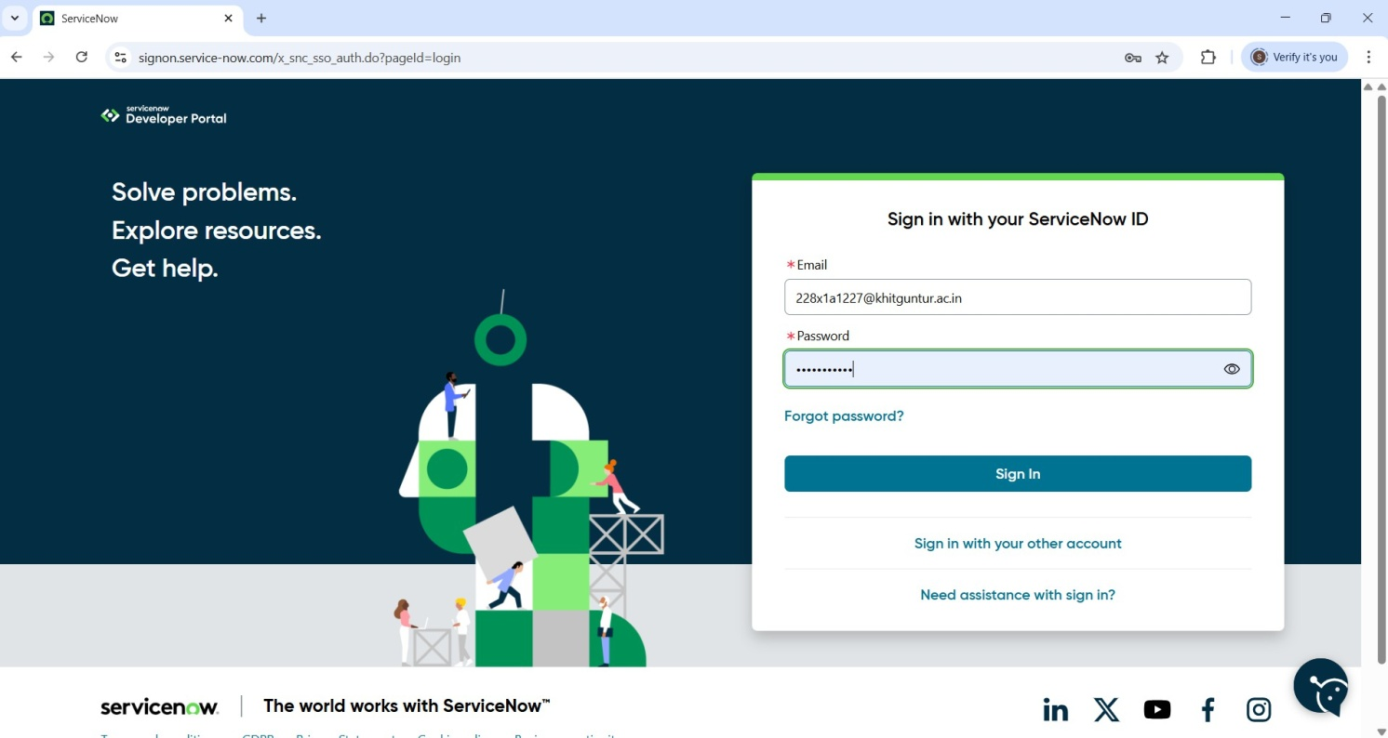

* RequestaPersonalDeveloperInstance(PDI)
  + Clickontheprofileiconatthetop-rightcorner.
  + Select“ManageInstance”orgodirectlytothelink.
  + Click“RequestInstance”.
  + Choosethelatestversion(defaultselectionisrecommended).
* AccessyourInstance
  + You’llgetaninstanceURL(https://dev225052.service-now.com)
  + Click“OpenInstance”tolaunchit.
  + Youradmincredentials(username&password)willbeshown-copy andsavethemsecurely.
  + LogintoYour Instance.

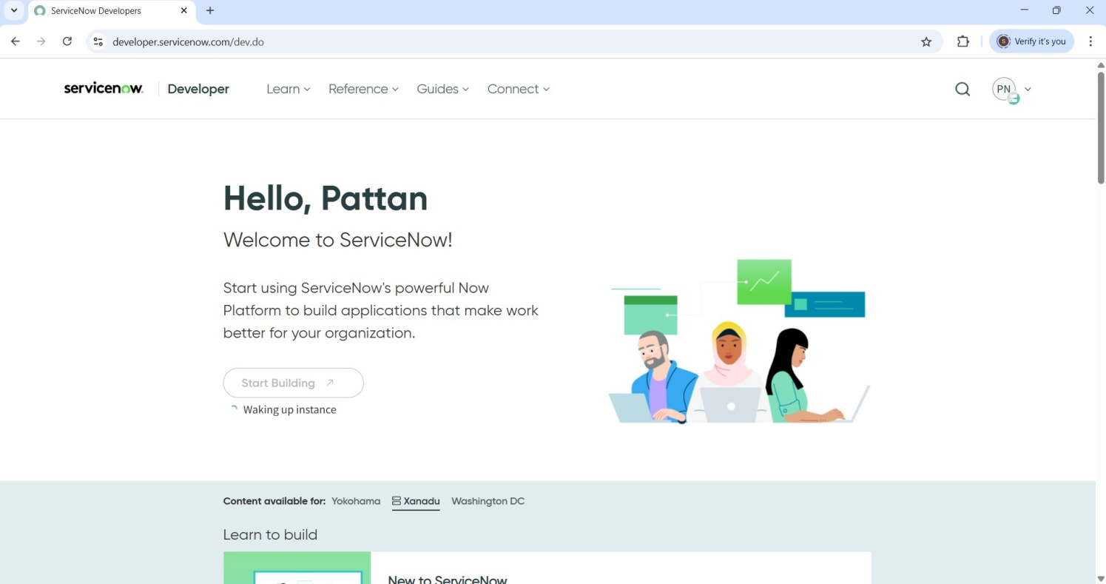

Usage:

* UsetheApplicationNavigator(leftsidebar)toexploremoduleslike:
  + Incident,Problem,ChangeManagement.
  + ServiceCatLog.
  + ConfigurationManagement(CMDB).
  + WorkflowEditor/FlowDesigner.
* UseAppEngineStudioorServiceNowStudiotobuildorcustomizeapps.

Step2: CreationofNewUpdateSet

Before starting the actual developmentof the project, itis essential to create an**Update Set** in ServiceNow. The update set acts like a **container** or **workspace** that automatically tracks every change or customization made in the platform.

Thisincludes:

* Creatingnewtables
* Designingforms
* Addingworkflowsorscripts
* ChangingUIelements
* Settingaccessrules

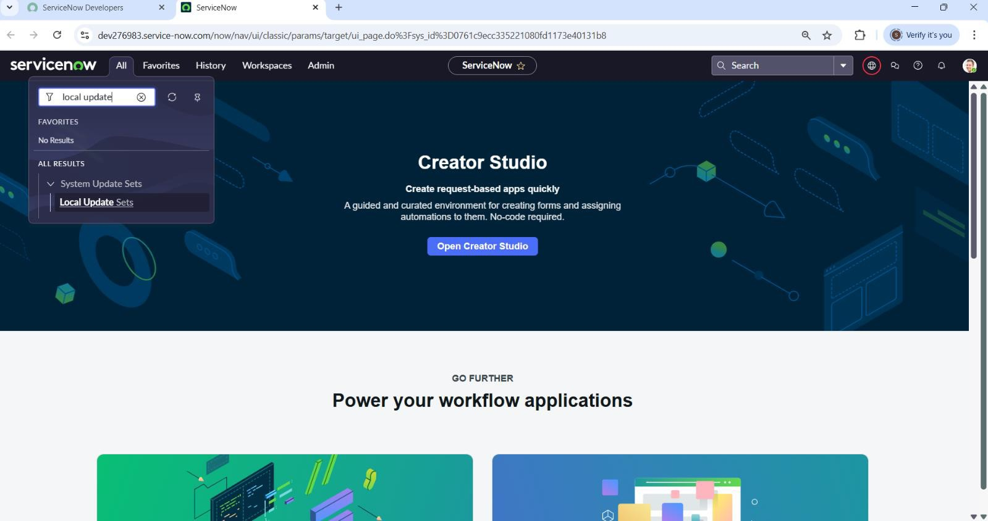

EntertheDetailsas

Name:EducationalOrganisation.

Then click on Submit and Make current. From this point forward, all the customizations related to the project were automatically recorded under this update set. This ensured a clean and controlled development environment.

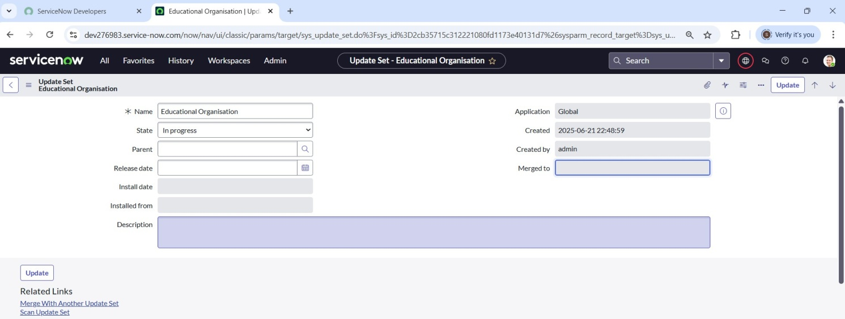

Step3:CreationofTable

Afterdesigningtheupdateset,thenextmajormilestonewastobeginbuildingthe**databasetables**forthe Educational Organization system.

1. CreationofSalesforceTable

The first table created was called **Salesforce**, which stores basic studentand admission-relatedinformation suchas:AdmissionDate,AdminNumber,GradeandStudentNameetc.This tableactsasthe**foundation**for storing structured student records.

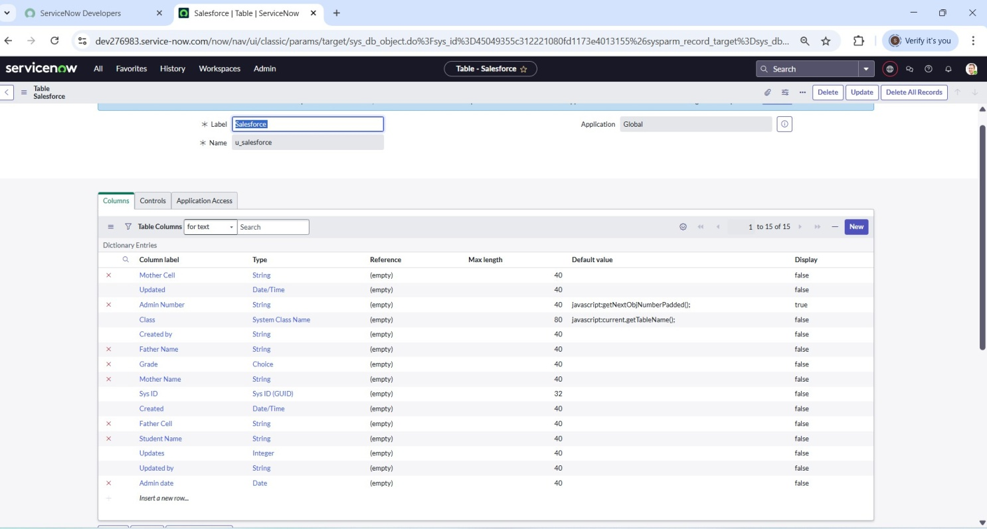

1. CreatingAdmissionTable:

The **Admission Table** was created to manage and track the details of student admissions. It extends from the **Salesforce table**, meaning it inherits all basic student fields while allowing admission-specific additions.

StepsFollowedtoCreatetheAdmissionTable

* + TableSetup
    - TableName:Admission
    - Extendedfrom:Salesforce(inheritsstudentdetailslikename,contact)
    - AddedtoApplicationMenu:Salesforce
    - Madeavailableasaseparatemoduleintheleftnavigationpane
  + ColumnConfiguration
    - AdmissionDate
    - Grade
    - PurposeofJoin
    - Father’s&Mother’sContact
    - AdmissionStatus
    - SchoolandSchoolArea
    - Fee,Pincode,andComments
  + ChoiceFields

For several fields, choice lists were configured to maintain consistency and improve user experience. These included:

|  |  |
| --- | --- |
| **Field** | **ChoicesConfigured** |
| Pincode | 509358,500079,500081 |
| PurposeofJoin | Tuition,Coaching,Teacher |
| School | Stanley,NareshIt |
| School Area | NearMarket,NearBusstand |

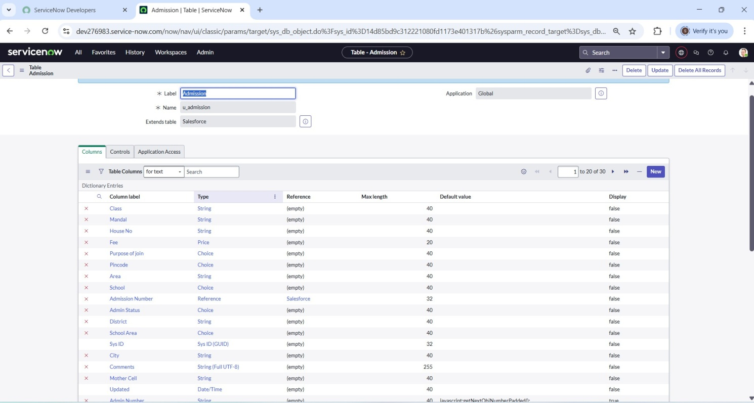

1. CreatingStudentProgressTable

The Student ProgressTable is designed to storethe academic performance details ofeach student. This table plays a vital role in tracking individual subject marks, calculating totals, and deriving overall results such as percentage and pass/fail status.

TableSetup

* + TableName:StudentProgress
  + Addedasaseparatemoduleunderthe**Salesforce**applicationmenu
  + Independenttablecreatedwithoutextension(asitholdsspecificperformancedata

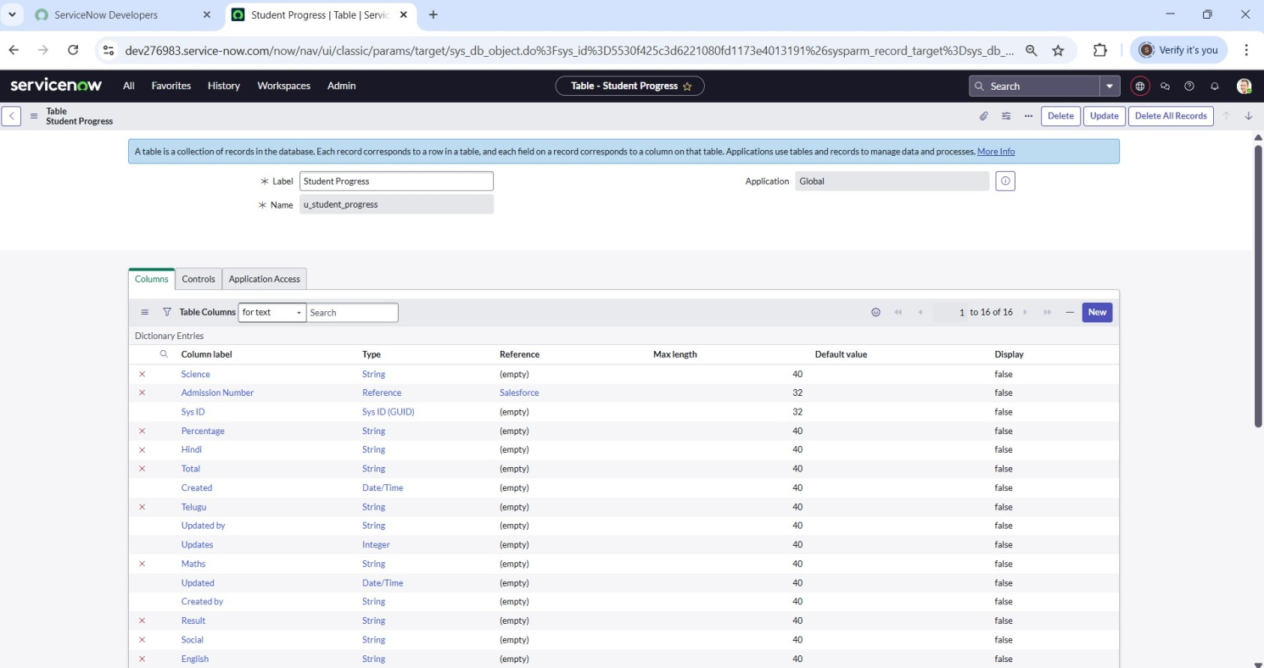

Step4: Form Layout& FormDesign

ConfiguringFormLayoutforStudentProgressTable

AftercreatingtheStudentProgress Table,wesetup theform layouttomakesureall importantfieldsappear in the right order when viewing or editing student records.

Hereweselectthefieldsfromreferencefieldadmissiontablethenthefieldsformedlike:

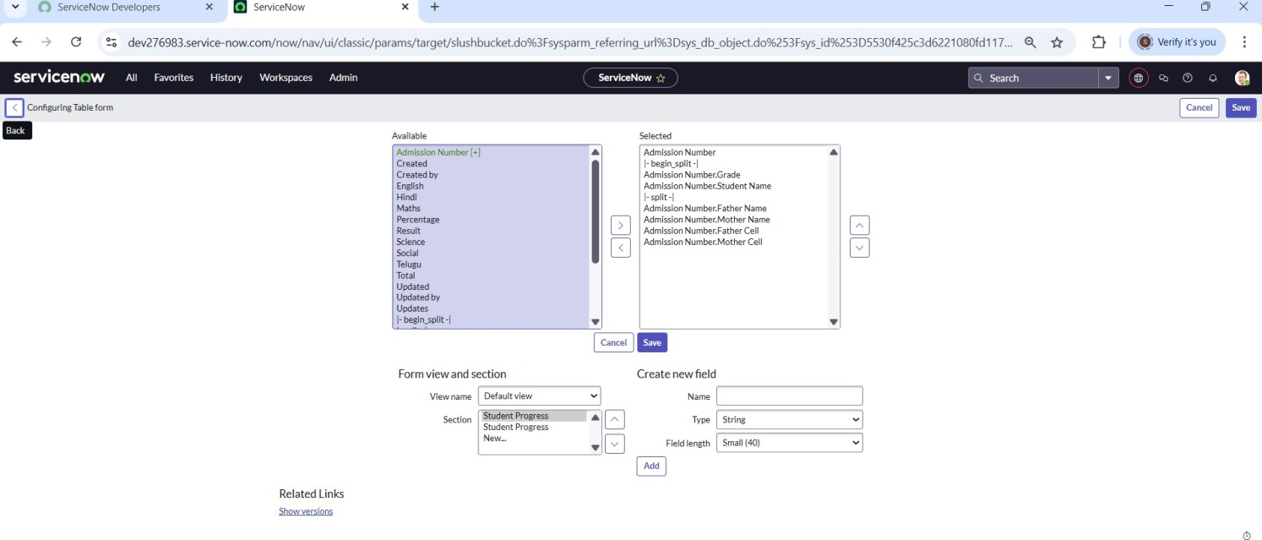

**Creating Form Design for Admission Table**: To make theform easy to use and display all necessary fields properly,we designed theform layoutfor the Admission Table using the Form Designer**.**

StepstoDesigntheForm:

1. Goto**FormDesigner**.
2. Choosethetable(e.g.,Admissionorstudentdata)from thelist.
3. SelectThetableSalesforce(u_salesforce)
4. Fromthe**Fields**panelontheleft,draganddroptherequiredfieldsintothelayoutarea:
   * AdmissionNumber
   * Grade
   * StudentName
   * FatherName
   * MotherName
   * FatherContact
   * MotherContact
5. Organizethemintwocolumnsforbetterstructure(asshowninimage).
6. Afterplacingallfields,click**Save**.

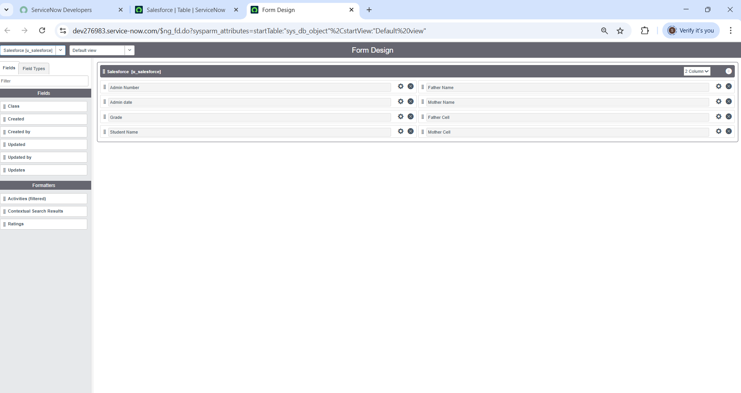

LikethiswehavedesigntheformforAdmissiontableandStudentProgresstableasshowninimage

Step5:Creating NumberMaintenanceforAdminNumber

NumberMaintenanceisusedtoautomaticallygenerateuniquenumbers(likeAdmissionIDs)in ServiceNow. Steps to Create Number Maintenance for Admin Number:

1. GotoNumberMaintenancemodule.
2. ClickNewtocreateanewnumberrecord.
3. Enterthefollowing:
   * Name:Salesforce
   * Prefix:SAL
4. ClickSubmittosavetherecord.

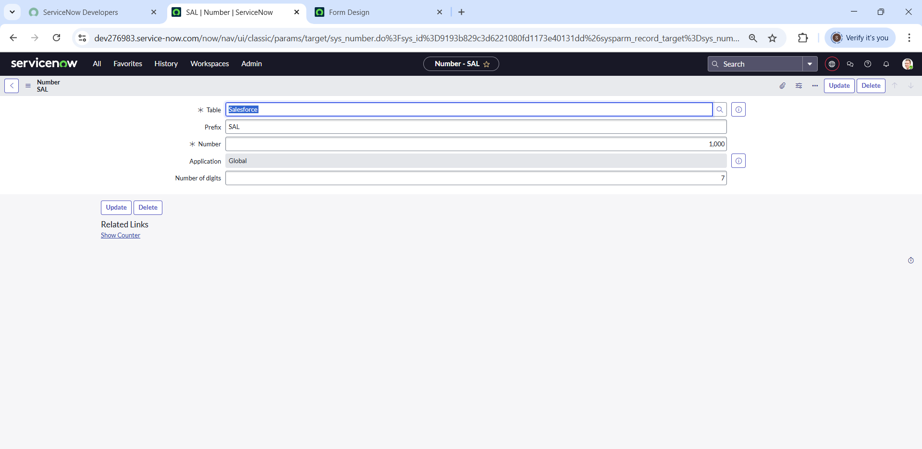

Step6:ProcessFlow

CreatingProcessFlowforAdmissionTable

Steps:

1. Goto:All→ProcessFlow→New
2. Fillintherequireddetails(like Tablename=Admission).
3. Right-clickonthetogglebarandclickSave.
4. Aftersaving,changetheNameandLabelforeachstage.
5. UseInsertandStaytoaddeachflowstatusonebyone.
6. StatusNamesinOrder:NewInProgressJoinedRejectedRejoinedClosedCancelled.

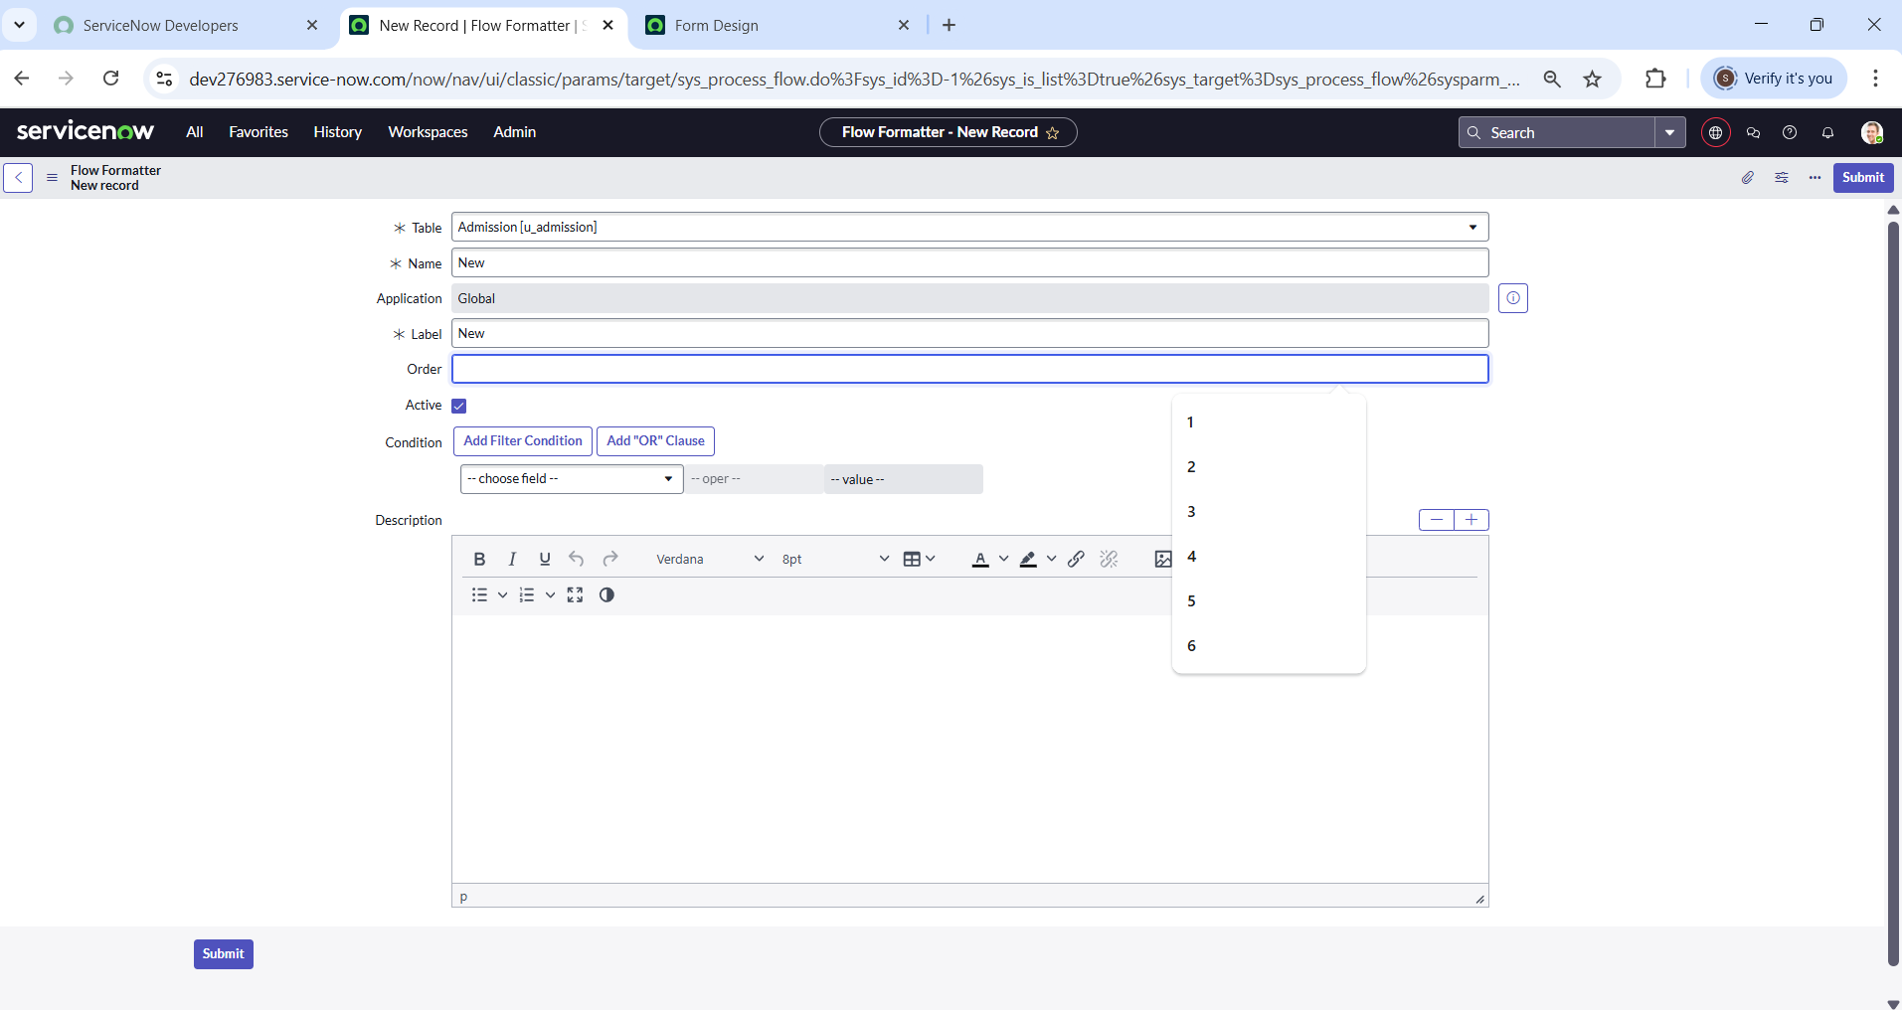

1. Likethiswehavetocreateflowforremaining6Andordershouldbeinabovementionedorder.

Step7:ClientScript

Auto-PopulateClientScript–Admission Table

Thisscript isused to automaticallyfillin student detailsontheadmission formbased ontheselected admission number. Steps to Create the Script:

1. Goto:All→ClientScripts→New
2. Fillintheform:
   * Table:Admission
   * UIType:Mobile/servicePortal
   * Type:onChange
   * FieldName:AdminNumber
3. CheckIsolateScript
4. Andwritethecode

BelowimageisabouttheAutoPopulateScript

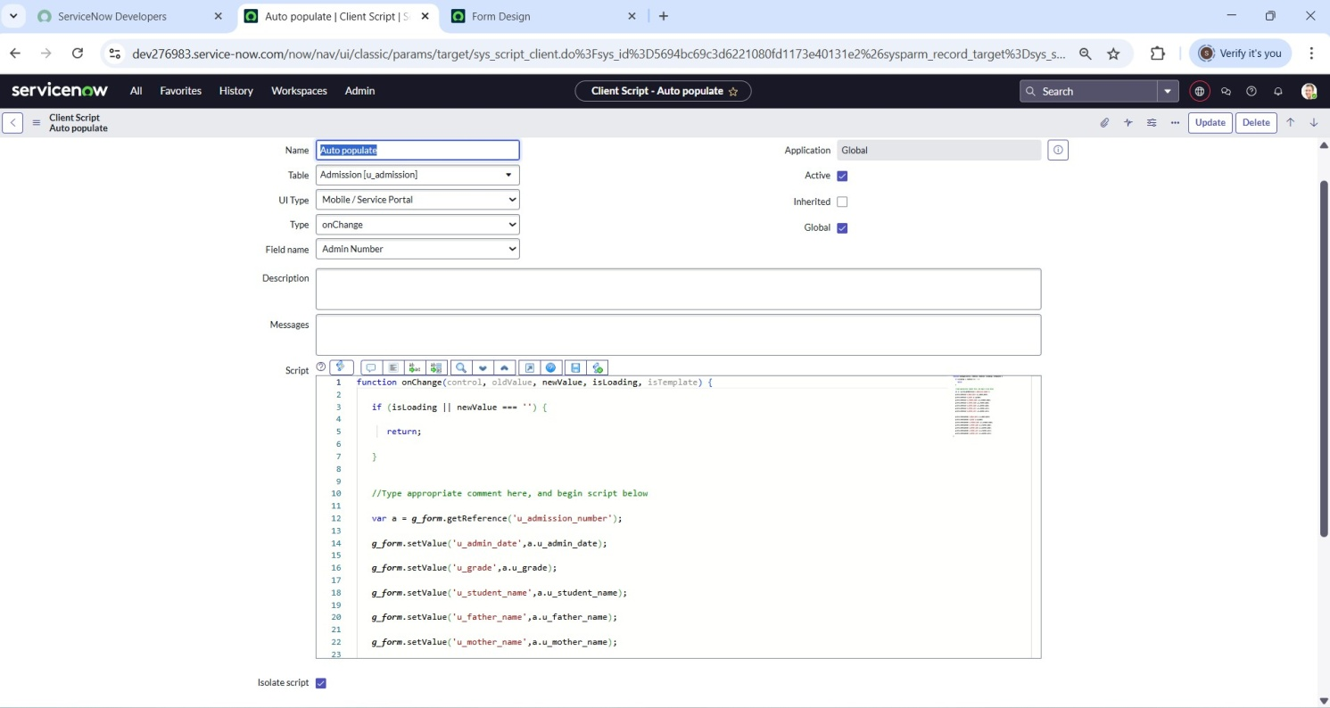

Likethiswehavetocreateclientscriptforpincode,disablefields,totalupdate,result,percentage.

Step8:Result:

* **AdmissionTable**

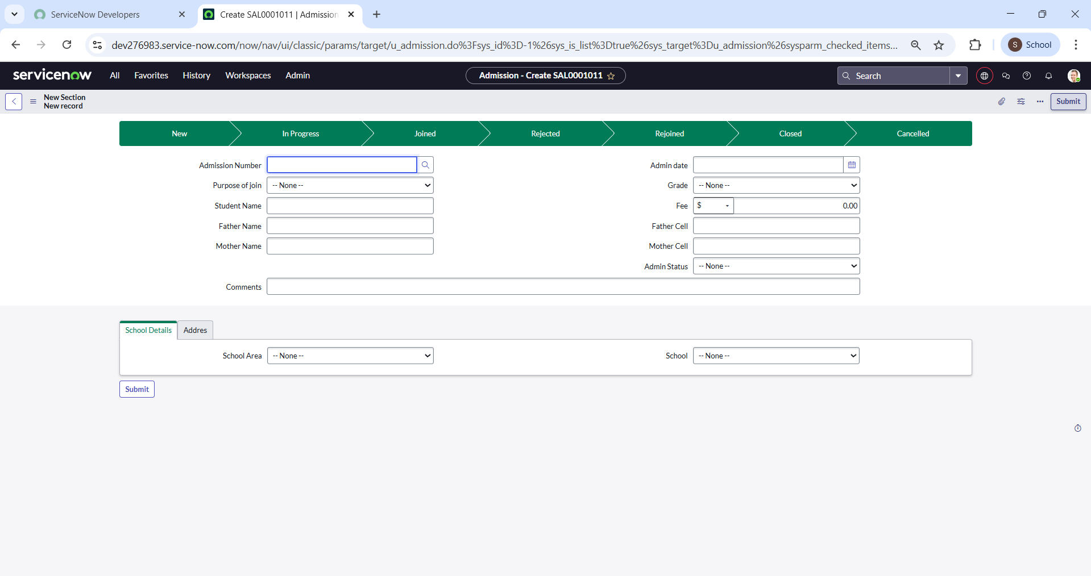

* **SalesforceTable**

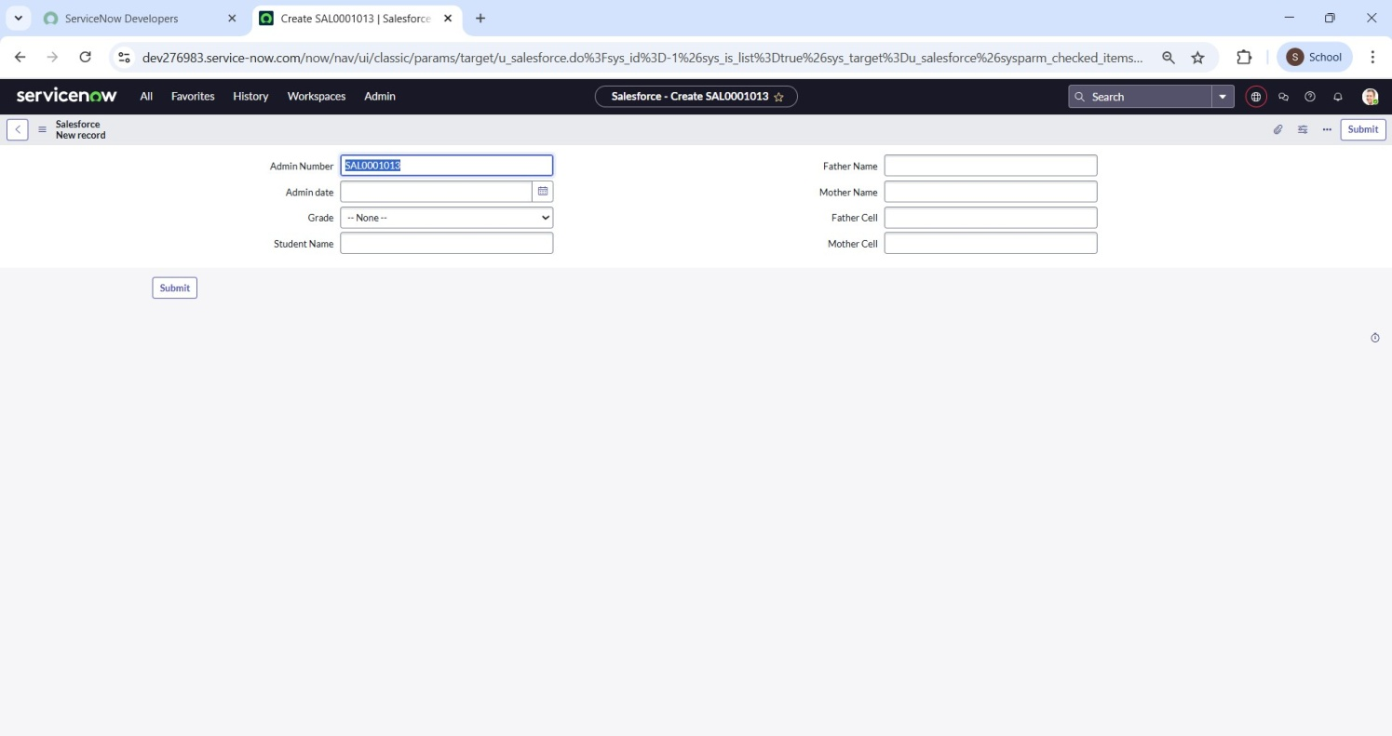

* **StudentProgressTable**

